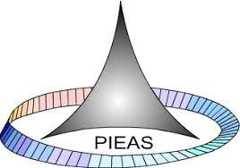

PAKISTAN INSTITUTE OF ENGINEERING AND APPLIED SCIENCES

***Computing Fundamentals & Programming***

**FALL 2020**

Laboratory Exercise-12

Department: Physics

Name: Umar Shifaqat

Serial No. 43

Roll No. BS-20-GB-100864

Date: DECEMBER 28, 2020

**HOME TASKS**

**HOME TASK 01**

**Write a program to print the memory address of all elements of an array, see if the array elements occupy consecutive memory locations**

**INPUT**

#include<stdio.h>

#include<conio.h>

void main()

{

int i,array[]={1,2,3,4,5,6,7,8,9,0};

for(i=0;i<10;i++)

printf("Adress of %dth element is:\t%d\n",i+1,&array[i]);

getch();

}

**OUTPUT**

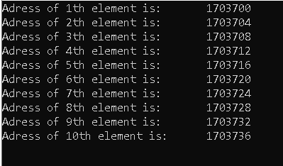

**The elements don’t occupy consecutive memory locations. Their locations differ by 4.**

**HOME TASK 02**

**Using the sizeof( ) function, find the size of the memory addresses of various variable and compare their values, is size of all memory addresses same?**

**INPUT**

#include<stdio.h>

#include<conio.h>

void main()

{

int i=1;

float f=2.1;

char c='u';

double d=2.34;

printf("The size of integer variable is: \t \'%d\'\n",sizeof(i));

printf("The size of float variable is: \t \'%d\'\n",sizeof(f));

printf("The size of double variable is: \t \'%d\'\n",sizeof(d));

printf("The size of character variable is: \t \'%d\'\n",sizeof(c));

getch();

}

**OUTPUT**

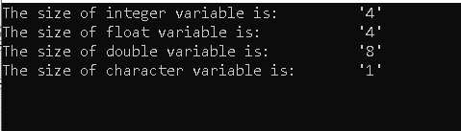

**The size of all memory addresses is not same.**

**HOME TASK 03**

**Without using the sizeof( ) function try to find how much space is occupied by a single element of an integer array.**

**INPUT**

#include<stdio.h>

#include<conio.h>

void main()

{

int array[]={1,2};

int *p1=&array[0];

int *p2=&array[1];

printf("The size of int is %d",p2-p1);

getch();

}

**OUTPUT**



**HOME TASK 04**

**Try to write a program that calculates average of three numbers, you have done this program before, here try to do it using pointers, i.e. use only pointers.**

**INPUT**

#include<stdio.h>

#include<conio.h>

void main()

{

int x,y,z,average;

int *ptrx=&x;

int *ptry=&y;

int *ptrz=&z;

printf("\n\tEnter three numbers to find their average:");

scanf("%d%d%d",&x,&y,&z);

average=(*ptrx+*ptry+*ptrz)/3;

printf("\n\tThe average of numbers is %d",average);

getch();

getch();

}

**OUTPUT**

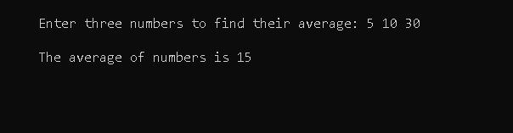

**HOME TASK 05**

**Try to write a program that swaps the values of two integer variables, you have to do it using pointers i.e. any modifications in the values of integer variables should be done using pointers.**

**INPUT**

#include<stdio.h>

#include<conio.h>

void main()

{

int first=12,second=18,swap;

int *ptr1=&first;

int *ptr2=&second;

int *ptr3;

printf("Before Swapping:\n\t1st number is %d ,\t2nd number is %d\n",*ptr1,*ptr2);

ptr3=ptr1;

ptr1=ptr2;

ptr2=ptr3;

printf("After swapping:\n\t1st number is %d ,\t2nd number is %d\n",*ptr1,*ptr2);

getch();

return 0;

}

**OUTPUT**

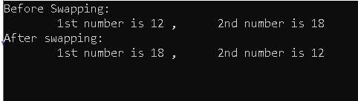

**HOME TASK 06**

**Create a program that declare a int array of 10 elements, print the following addresses**

**Q: Address of the block pointed by array**

**R: Address of the first element of the array**

**S: Address of every element of the array**

**T: Swap the values of the array element by pointer operations**

**U: Add all values of the array members using starting address of the array**

**V: Find the different between the address of the first and last element of the array and try to calculate the memory occupied by this array**

**INPUT**

#include<Stdio.h>

#include<conio.h>

void main()

{

int i,a[10]={0,1,2,3,4,5,6,7,8,9};

//Q

printf("The adress of the block is :%d\n",a);

//R

printf("Adress of the first element of array is :%d\n",a);

//S

for(i=0;i<10;i++)

printf("The adress of element-%d is: %d\n",i+1,a+i);

//T

int swap;

printf("Before swapping: \n\t 1st elemet is %d, 5th element is %d\n",*a,*(a+4));

swap=*a;

*a=*(a+4);

*(a+4)=swap;

printf("After swapping: \n\t 1st elemet is %d, 5th element is %d\n",*a,*(a+4));

//U

int sum=0;

for(i=0;i<10;i++)

sum+=*(a+i);

printf("The Sum of all Elements is: %d\n",sum);

//V

int *p,*q;

q=a;

p=a+9;

printf("The adress of 1st element is: %d\n",q);

printf("The adress of last element is: %d\n",p);

printf("\nThe memory occupied by the array is: %d",(p-q)*4);

getch();

}

**OUTPUT**

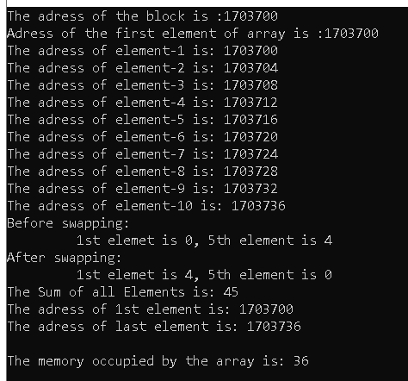

**THE END**